AMRITA VISHWA VIDYAPEETHAM
Department of Computer Science and Engineering
15CSE386 Computer Networks Lab

Lab Exercise: 4–Getting started with Wireshark

- Familiarize yourself with the popular packet sniffer application called Wireshark

In this lab using wireshark simulator, you’ll get acquainted with some simple packet captures and observations.

About the tool

The basic tool for observing the messages exchanged between executing protocol entities is called a packet sniffer. As the name suggests, a packet sniffer captures (“sniffs”) messages being sent/received from/by your computer; it will also typically store and/or display the contents of the various protocol fields in these captured messages. A packet sniffer itself is passive. It observes messages being sent and received by applications and protocols running on your computer, but never sends packets itself. Similarly, received packets are never explicitly addressed to the packet sniffer. Instead, a packet sniffer receives a copy of packets that are sent/received from/by application and protocols executing on your machine.

Figure 1 shows the structure of a packet sniffer. At the right of Figure 1 below are the protocols (in this case, Internet protocols) and applications (such as a web browser or ftp client) that normally run on your computer. The packet sniffer, shown within the dashed rectangle in Figure 1 is an addition to the usual software in your computer, and consists of two parts. The packet capture library receives a copy of every link-layer frame that is sent from or received by your computer. Recall from the discussion with respect to layered architecture the messages exchanged by higher layer protocols such as HTTP, FTP, TCP, UDP, DNS, or IP all are eventually encapsulated in link-layer frames that are transmitted over physical media such as an Ethernet cable. In Figure 1, the assumed physical media is an Ethernet, and so all upper-layer protocols are eventually encapsulated within an Ethernet frame. Capturing all link-layer frames thus gives you all messages sent/received from/by all protocols and applications executing in your computer.

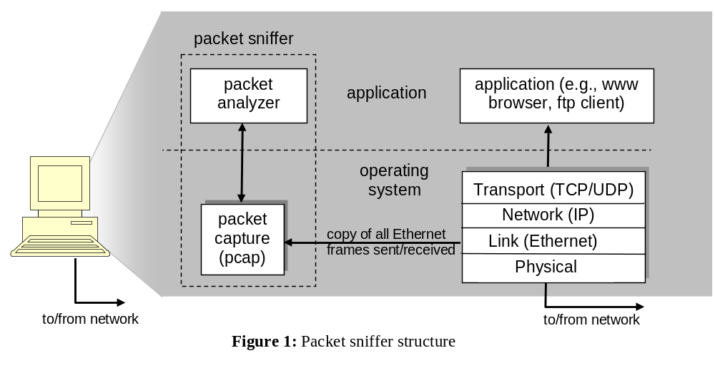

The second component of a packet sniffer is the packet analyzer, which displays the contents of all fields within a protocol message. In order to do so, the packet analyzer must “understand” the structure of all messages exchanged by protocols. For example, suppose we are interested in displaying the various fields in messages exchanged by the HTTP protocol in Figure 1. The packet analyzer understands the format of Ethernet frames, and so can identify the IP datagram within an Ethernet frame. It also understands the IP datagram format, so that it can extract the TCP segment within the IP datagram. Finally, it understands the TCP segment structure, so it can extract the HTTP message contained in the TCP segment. Finally, it understands the HTTP protocol and so, for example, knows that the first bytes of an HTTP message will contain the string “GET,” “POST,” or “HEAD,” .
We will be using the Wireshark packet sniffer [http://www.wireshark.org/] for the lab, allowing us to display the contents of messages being sent/received from/by protocols at different levels of the protocol stack. (Technically speaking, Wireshark is a packet analyzer that uses a packet capture library in your computer). Wireshark is a free network protocol analyzer that runs on Windows, Linux/Unix, and Mac computers. It’s an ideal packet analyzer having rich functionality that includes the capability to analyze hundreds of protocols, and a well-designed user interface. It operates in computers using Ethernet, serial (PPP and SLIP), 802.11 wireless LANs, and many other link-layer technologies (if the OS on which it's running allows Wireshark to do so).
Running Wireshark

When you run the Wireshark program, you’ll get a startup screen, as shown below:

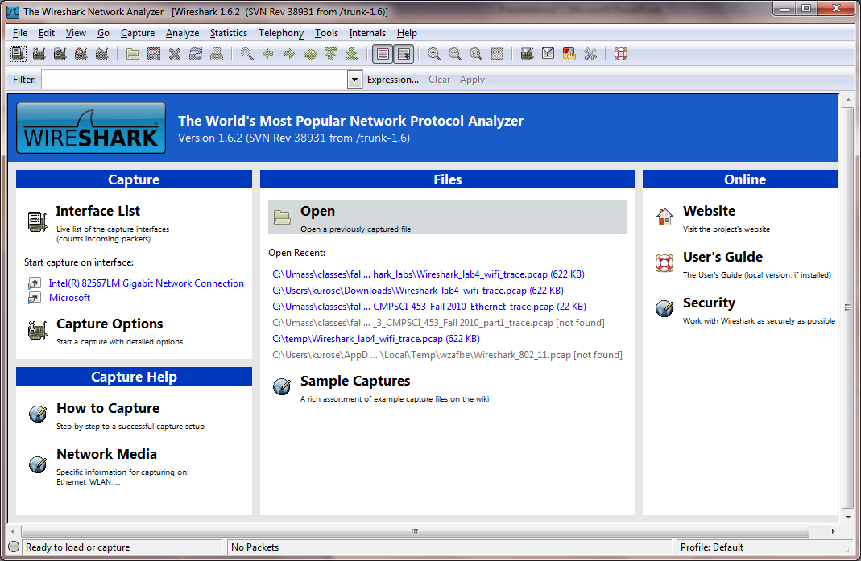
Figure 2: Initial Wireshark Screen

Take a look at the upper left hand side of the screen – you’ll see an “Interface list”. This is the list of network interfaces on your computer. Once you choose an interface, Wireshark will capture all packets on that interface. In the example above, there is an Ethernet interface (Gigabit network Connection) and a wireless interface (“Microsoft”).

If you click on one of these interfaces to start packet capture (i.e., for Wireshark to begin capturing all packets being sent to/from that interface), a screen like the one below will be displayed, showing information about the packets being captured. Once you start packet capture, you can stop it by using the Capture pull down menu and selecting Stop.

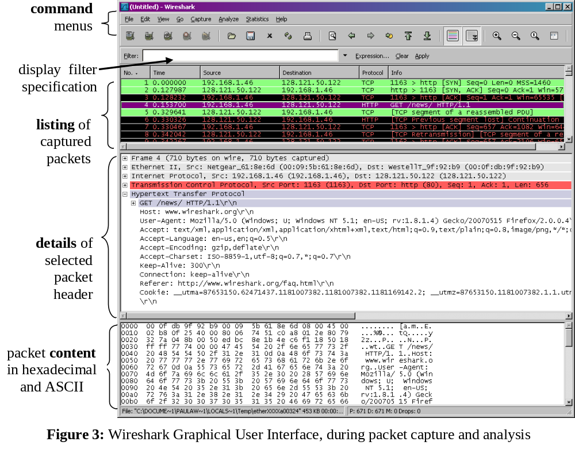
The Wireshark interface has five major components:
- The command menus are standard pulldown menus located at the top of the window. Of interest to us now are the File and Capture menus. The File menu allows you to save captured packet data or open a file containing previously captured packet data, and exit the Wireshark application. The Capture menu allows you to begin packet capture.
- The packet-listing window displays a one-line summary for each packet captured, including the packet number (assigned by Wireshark; this is not a packet number contained in any protocol’s header), the time at which the packet was captured, the packet’s source and destination addresses, the protocol type, and protocol-specific information contained in the packet. The packet listing can be sorted according to any of these categories by clicking on a column name. The protocol type field lists the highest-level protocol that sent or received this packet, i.e., the protocol that is the source or ultimate sink for this packet.
- The packet-header details window provides details about the packet selected (highlighted) in the packet-listing window. (To select a packet in the packet-listing window, place the cursor over the packet’s one-line summary in the packet-listing window and click with the left mouse button.). These details include information about the Ethernet frame (assuming the packet was sent/received over an Ethernet interface) and IP datagram that contains this packet. The amount of Ethernet and IP-layer detail displayed can be expanded or minimized by clicking on the plus minus boxes to the left of the Ethernet frame or IP datagram line in the packet details window. If the packet has been carried over TCP or UDP, TCP or UDP details will also be displayed, which can similarly be expanded or minimized. Finally, details about the highest-level protocol that sent or received this packet are also provided.
- The packet-contents window displays the entire contents of the captured frame, in both ASCII and hexadecimal format.
- Towards the top of the Wireshark graphical user interface, is the packet display filter field, into which a protocol name or other information can be entered in order to filter the information displayed in the packet-listing window (and hence the packet-header and packet-contents windows). In the example below, we’ll use the packet-display filter field to have Wireshark hide (not display) packets except those that correspond to HTTP messages.

Taking Wireshark for a Test Run

The best way to learn about any new piece of software is to try it out! We’ll assume that your computer is connected to the Internet via a wired Ethernet interface. Indeed, I recommend that you do this first lab on a computer that has a wired Ethernet connection, rather than just a wireless connection. Do the following

- Start up your favorite web browser, which will display your selected homepage.

- Start up the Wireshark software. You will initially see a window similar to that shown in Figure 2. Wireshark has not yet begun capturing packets.

- To begin packet capture, select the Capture pull down menu and select Interfaces. This will cause the “Wireshark: Capture Interfaces” window to be displayed, as shown in Figure 4.

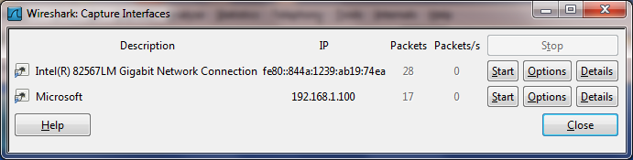 Figure 4: Wireshark Capture Interface Window

- You’ll see a list of the interfaces on your computer as well as a count of the packets that have been observed on that interface so far. Click on Start for the interface on which you want to begin packet capture (the listing will look different in your computer). Packet capture will now begin - Wireshark is now capturing all packets being sent/received from/by your computer!

- Once you begin packet capture, a window similar to that shown in Figure 3 will appear. This window shows the packets being captured. By selecting Capture pulldown menu and selecting Stop, you can stop packet capture. But don’t stop packet capture yet. Let’s capture some interesting packets first. To do so, we’ll need to generate some network traffic. Let’s do so using a web browser, which will use the HTTP protocol that we will study in detail in class to download content from a website.

- While Wireshark is running, enter the URL:
http://vidya.ettimadai.net/curriculumResourceGuide/cs302.html
and have that page displayed in your browser. In order to display this page, your browser will contact the HTTP server at vidya server and exchange HTTP messages with the server in order to download this page, as discussed in section 2.2 of the text. The Ethernet frames containing these HTTP messages (as well as all other frames passing through your Ethernet adapter) will be captured by Wireshark.

- After your browser has displayed the page (which shows the different materials available in Vidya for networking), stop Wireshark packet capture by selecting stop in the Wireshark capture window. The main Wireshark window should now look similar to Figure 3. You now have live packet data that contains all protocol messages exchanged between your computer and other network entities! The HTTP message exchanges with the vidya web server should appear somewhere in the listing of packets captured. But there will be many other types of packets displayed as well (see, e.g., the many different protocol types shown in the Protocol column in Figure 3). Even though the only action you took was to download a web page, there were evidently many other protocols running on your computer that are unseen by the user. We’ll learn much more about these protocols as we progress through the text! For now, you should just be aware that there is often much more going on than “meet’s the eye”!

- Type in “http” (without the quotes, and in lower case – all protocol names are in lower case in Wireshark) into the display filter specification window at the top of the main Wireshark window. Then select Apply (to the right of where you entered “http”). This will cause only HTTP message to be displayed in the packet-listing window.
- Find the HTTP GET message that was sent from your computer to the vidya HTTP server. (Look for an HTTP GET message in the “listing of captured packets” portion of the Wireshark window (see Figure 3) that shows “GET” followed by the URL that you entered. When you select the HTTP GET message, the Ethernet frame, IP datagram, TCP segment, and HTTP message header information will be displayed in the packet-header window. By clicking on ‘+’ and ‘-‘ right-pointing and down-pointing arrowheads to the left side of the packet details window, minimize the amount of Frame, Ethernet, Internet Protocol, and Transmission Control Protocol information displayed. Maximize the amount information displayed about the HTTP protocol. Your Wireshark display should now look roughly as shown in Figure 5. (Note, in particular, the minimized amount of protocol information for all protocols except HTTP, and the maximized amount of protocol information for HTTP in the packet-header window).
- Exit Wireshark

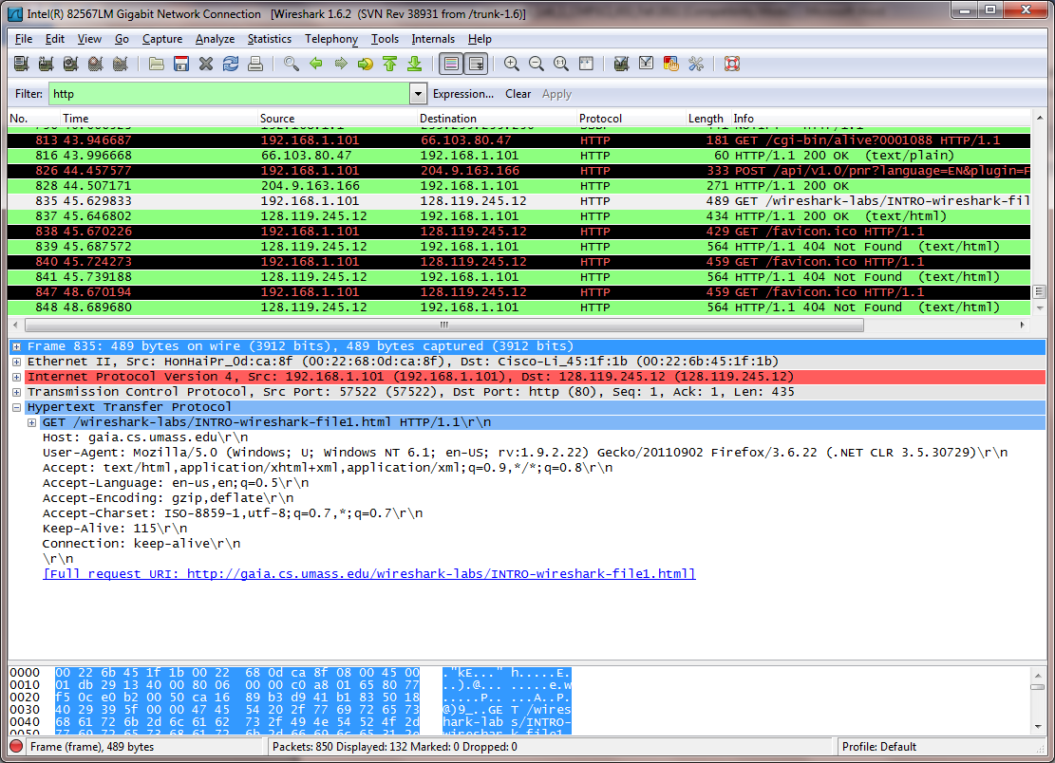
Figure 5: Wireshark window after step 9

Wireshark Lab 2: Questions
Answer the following questions, based on your Wireshark experimentation.Write it in your observation notebook.

- List 3 different protocols that appear in the protocol column in the unfiltered packet-listing window.

- Identify the layered architecture for any application running in wireshark and write down the protocols running in each layer.

- What is the job of the packet capture and packet analyzer? Write a sentence for each.

- Name the interfaces on your computer after running wireshark?

- How long did it take from when the HTTP GET message was sent until the HTTP OK reply was received? (By default, the value of the Time column in the packet-listing window is the amount of time, in seconds, since Wireshark tracing began. To display the Time field in time-of-day format, select the Wireshark View pull down menu, then select Time Display Format, then select Time-of-day.)

- What is the Internet address of the intranet.amritanet.edu? What is the Internet address of your computer? Where did you find this information in Wireshark?

- For the HTTP page request from your computer to the intranet server, what was the source port and what was the destination port?

- Print the two HTTP messages (GET and OK) referred to in question 2 above. To do so, select Print from the Wireshark File command menu, and select the “Selected Packet Only” and “Print as displayed” radial buttons, and then click OK.

- Record the number of packets that has been observed by your interface this far.

- What is the version of HTTP that is running on the browser? What HTTP version is running on the server?

- What language does your browser indicate that it can accept from the server?

- When was the HTML file that you were retrieving last modified by the server?

- Inspect the browser for HTTP Request and Response Messages
- Check for Conditional GET Mechanism
- List down the cookies that is stored in your browser.
- What Mail Retrieval Protocols is supported by gmail?

